

**MATHEMATICS  
METHODS**

**Test 5 –Differentiation and Applications of Differentiation**

**Semester 2 2016**

**Section Two – Calculator Assumed**

Time allowed for this section

Working time for this section: 30 minutes

Marks available: 28 marks

**Materials required/recommended for this section**

***To be provided by the supervisor***This Question/Answer Booklet  
Formula Sheet

***To be provided by the student***

Standard items: pens, pencils, pencil sharpener, eraser, correction fluid/tape, ruler, highlighters

Special items: drawing instruments, templates, notes on one unfolded sheet of A4 paper, and up to three calculators satisfying the conditions set by the Curriculum Council for this examination.

**Important note to candidates**

No other items may be used in this section of the paper. It is **your** responsibility to ensure that you do not have any unauthorised notes or other items of a non-personal nature in the room. If you have any unauthorised material with you, hand it to the supervisor **before** reading any further. All working out **must** be shown for full marks to be awarded.

1. (9 marks)
2. On the axes below, sketch the graph of y = x3 – 5x2 + 2x – 3 [3]

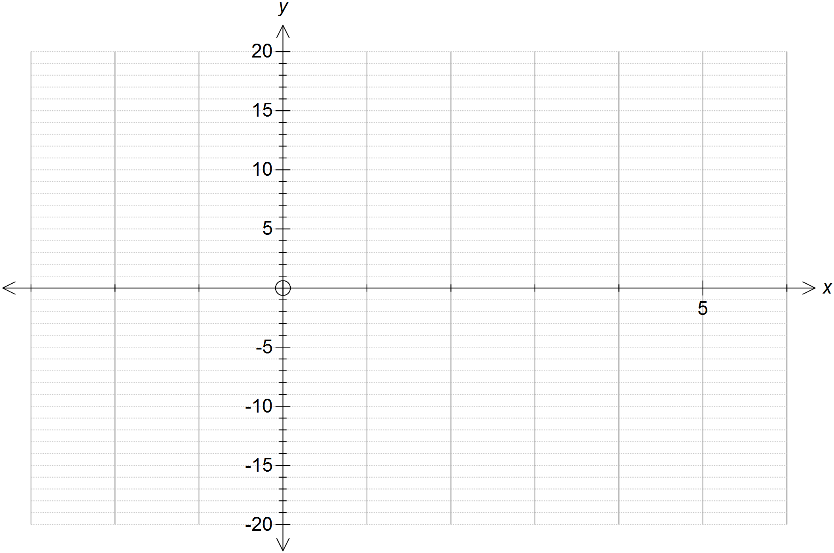

1. Show all of the x-intercepts and y-intercepts on the graph above. [2]
2. Find [1]



1. For what values of x does the tangent to y = x3 – 5x2 + 2x – 3 have a negative slope? [1]

1. Sketch the tangents to the curve, y = x3 – 5x2 + 2x – 3, at the points where x = -1 and

x = 4. [2]

1. (3 marks)

Given  determine:

1.  [1]
2.  [1]
3.  [1]
4. (2 marks)

Determine 

1. (4 marks)

Determine the derivative of  by using first principles.

1. (3 marks)  
   The volume of water flowing through a pipe is given by  , where *V* is the volume in litres and *t* is the time in minutes. Find the rate of water flow after 7 minutes.
2. (3 marks)

A model helicopter is flown so that it its height above the ground is given by  at *t* seconds, where the height is in metres. Find each of the following.

**a** Its height after 4 seconds. [1]

**b** Its velocity after 4 seconds. [2]

1. (4 marks)

Let  be the displacement function of a particle moving in a straight line, where *t* is in seconds and *s* is in metres. Find the acceleration when the velocity is 2.

**End of Test**